Real-Time Rendering

📘 Definition
# Source: AI Source: Provided by: [Data Path: Persons Table -> ID Column: 1, Name_En Column: Motasem Essam] -> From: [ChatGPT] on [5/2/2026]
Real-time rendering is a type of rendering where images are generated instantly (in real time) as the scene is changing. It is used when the system must respond immediately, usually at 24–120 frames per second (FPS).

🖥️ How real-time rendering works
# Source: AI Source: Provided by: [Data Path: Persons Table -> ID Column: 1, Name_En Column: Motasem Essam] -> From: [ChatGPT] on [5/2/2026]
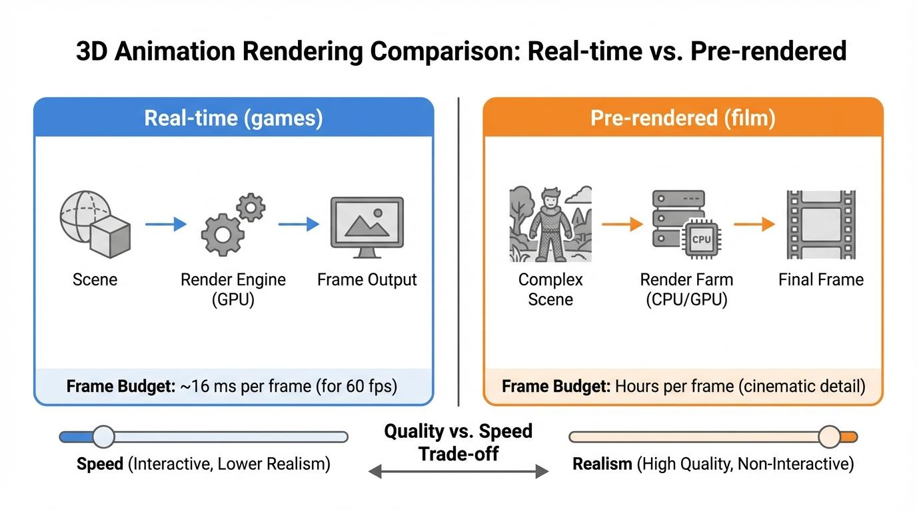
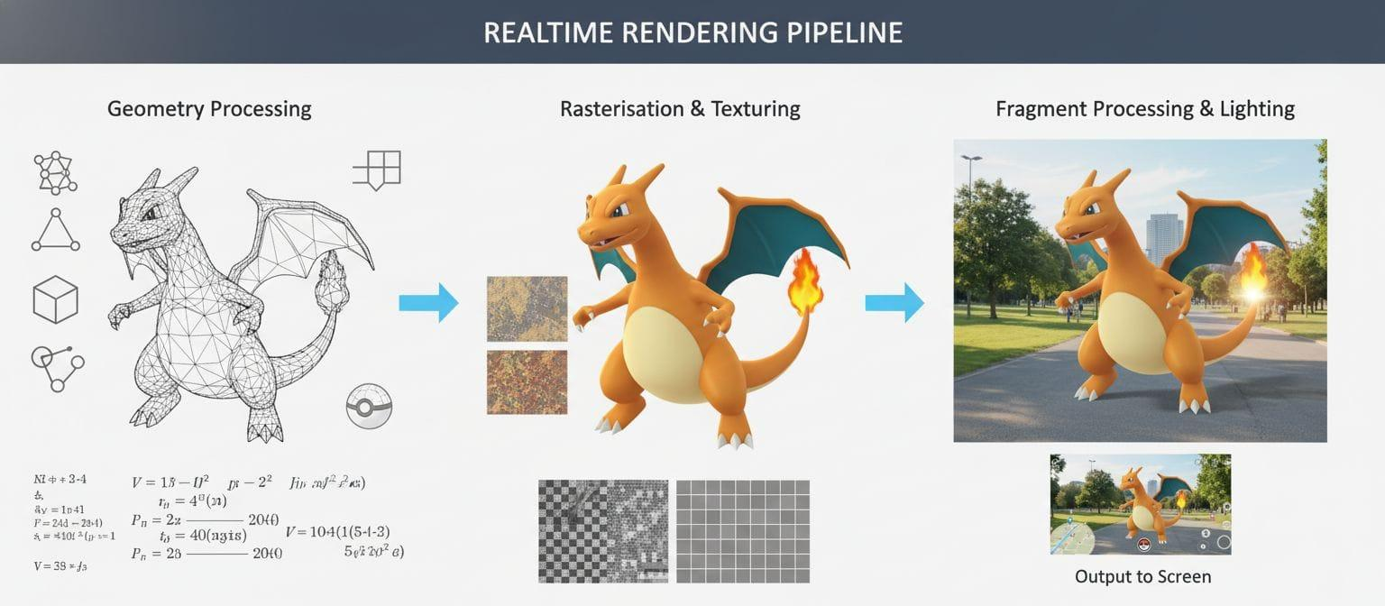
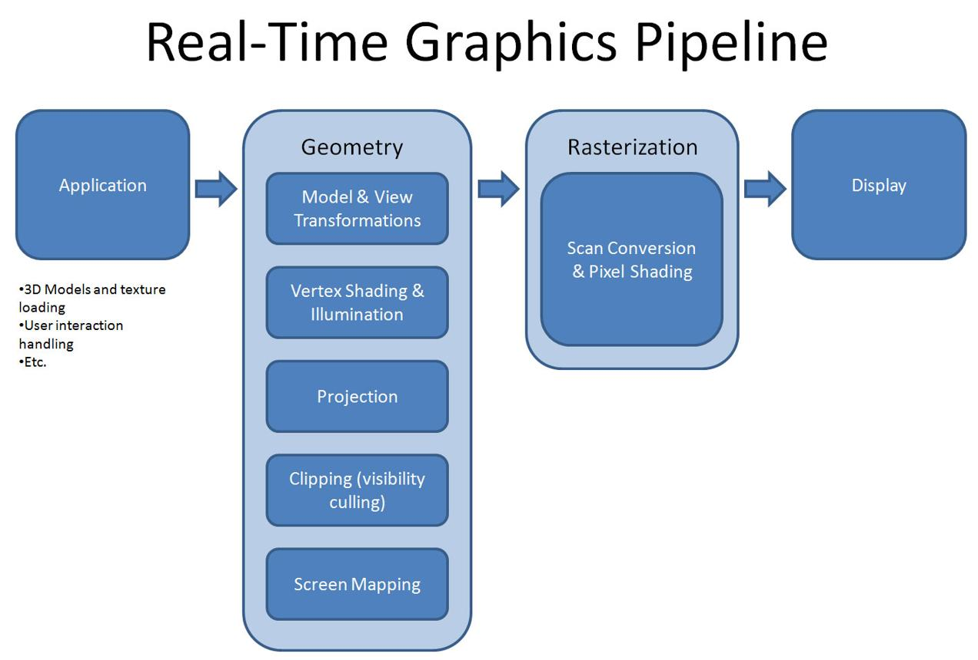
- The scene is processed many times per second
- The GPU quickly calculates lighting, textures, and shadows
- Every movement updates the image instantly
- Used for interactive systems

🧠 Simple example
# Source: AI Source: Provided by: [Data Path: Persons Table -> ID Column: 1, Name_En Column: Motasem Essam] -> From: [ChatGPT] on [5/2/2026]
Think of:
- 🎮 A video game where you move a character and everything updates instantly
- 🕶️ A VR headset where your view changes as you turn your head
- 🖱️ A 3D software viewport while designing objects

🎮 Where real-time rendering is used
# Source: AI Source: Provided by: [Data Path: Persons Table -> ID Column: 1, Name_En Column: Motasem Essam] -> From: [ChatGPT] on [5/2/2026]
- 🎮 Video games
- 🕶️ Virtual Reality (VR) and Augmented Reality (AR)
- 🧑‍💻 3D modeling software (Blender, Maya viewports)
- 🚗 Simulations (driving, flight simulators)

⚙️ Key features
# Source: AI Source: Provided by: [Data Path: Persons Table -> ID Column: 1, Name_En Column: Motasem Essam] -> From: [ChatGPT] on [5/2/2026]
- ⚡ Very fast rendering (instant results)
- 🎮 Used for interactive applications
- 💻 Optimized for GPU performance
- 🎯 Slightly lower quality than offline rendering

🚀 In short:
# Source: AI Source: Provided by: [Data Path: Persons Table -> ID Column: 1, Name_En Column: Motasem Essam] -> From: [ChatGPT] on [5/2/2026]
Real-time rendering = fast rendering that produces images instantly while the user interacts with the scene, like in games and VR.

